Collections

1. Employee Name List (ArrayList)
Scenario
A company HR department wants to store the names of employees who attended a training program.
Question
Write a Java program to:
Create an ArrayList<String>
Add employee names: Ramesh, Suresh, Priya, Anu, Karthik
Display all employee names in the order they were added.

Code:
import java.util.ArrayList;
public class EmployeeNameList {
public static void main(String[] args) {
ArrayList<String> employees = new ArrayList<>();
employees.add("Ramesh");
employees.add("Suresh");
employees.add("Priya");
employees.add("Anu");
employees.add("Karthik");
System.out.println("Employee Names:");
for (String name : employees) {
System.out.println(name);
}
}
}

Output:
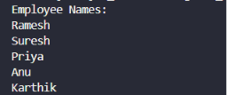

2. Restaurant Order Management (ArrayList)
Scenario
A restaurant stores the food items ordered by a customer.
Question
Write a Java program to:
Create an ArrayList<String>
Add items: Dosa, Idli, Pongal, Coffee
Remove Pongal
Display the updated order list and the total number of items.
Code:
import java.util.ArrayList;
public class RestaurantOrder {
public static void main(String[] args) {
ArrayList<String> order = new ArrayList<>();
order.add("Dosa");
order.add("Idli");
order.add("Pongal");
order.add("Coffee");
order.remove("Pongal");
System.out.println("Updated Order List:");
for (String item : order) {
System.out.println(item);
}
System.out.println("Total Items: " + order.size());
}
}
Output:
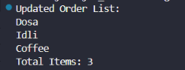

3. Online Course Enrollment (ArrayList)
Scenario
An online learning platform stores the names of students enrolled in a Java course.
Question
Write a Java program to:
Store 5 student names in an ArrayList
Check whether Meena is enrolled
Print Enrolled if the name exists; otherwise print Not Enrolled.
Code:
import java.util.ArrayList;
public class CourseEnrollment {
public static void main(String[] args) {
ArrayList<String> students = new ArrayList<>();
students.add("Ravi");
students.add("Meena");
students.add("Kiran");
students.add("Anitha");
students.add("Rahul");
if (students.contains("Meena")) {
System.out.println("Enrolled");
} else {
System.out.println("Not Enrolled");
}
}
}
Output:
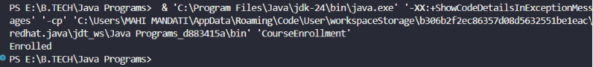

4. Unique Email Registration (Set)
Scenario
A website should not allow duplicate email registrations.
Question
Write a Java program to:
Create a HashSet<String>
Add emails: a@gmail.com, b@gmail.com, a@gmail.com, c@gmail.com
Display all unique email addresses
Display the total number of unique registered users.
Code:
import java.util.HashSet;
public class EmailRegistration {
public static void main(String[] args) {
HashSet<String> emails = new HashSet<>();
emails.add("a@gmail.com");
emails.add("b@gmail.com");
emails.add("a@gmail.com");
emails.add("c@gmail.com");
System.out.println("Unique Email Addresses:");
for (String email : emails) {
System.out.println(email);
}
System.out.println("Total Registered Users: " + emails.size());
}
}
Output:
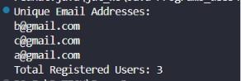

5. Library Book ID Tracking (Set)
Scenario
A library stores book ID numbers. The same book ID should not be entered twice.
Question
Write a Java program to:
Create a HashSet<Integer>
Add book IDs: 101, 102, 103, 101, 104
Display all unique book IDs
Print Duplicate Book ID Found when a duplicate ID is added.
Code:
import java.util.HashSet;
public class LibraryBookID {
public static void main(String[] args) {
HashSet<Integer> bookIds = new HashSet<>();
int[] ids = {101, 102, 103, 101, 104};
for (int id : ids) {
if (bookIds.add(id)) {
System.out.println("Added: " + id);
} else {
System.out.println("Duplicate Book ID Found");
}
}
System.out.println("\nUnique Book IDs:");
for (int id : bookIds) {
System.out.println(id);
}
}
}
Output:
